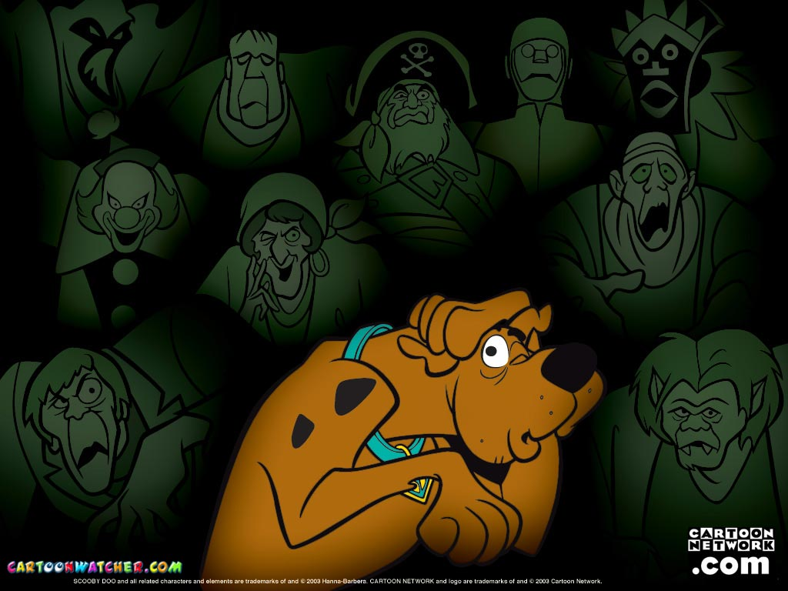

Welcome
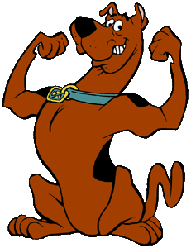
Hello!
I am Scooby Doo.

Hi! My name is Fred.

She is Daphne.


She is Velma
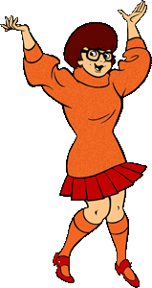

And He is my friend Shaggy.
We are friends!

No, it is not.
It is the Mistery Machine.
Is it a bus?
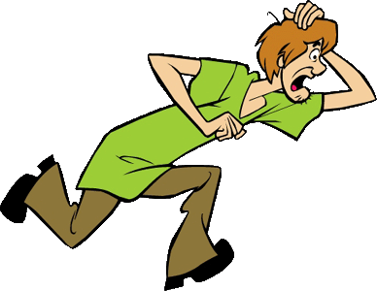

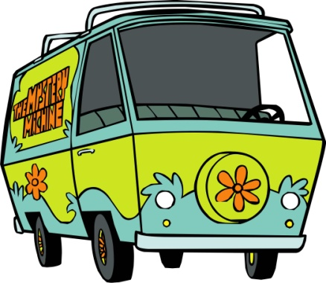

Verb to be (Am, Is, Are) positive form
Flash Cards
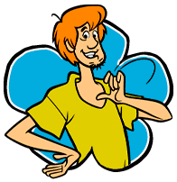  I | I am
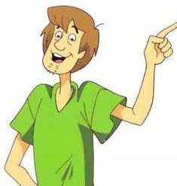  You | You are
He | He is
She | She is
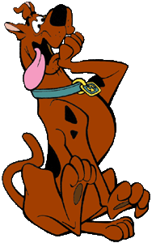  Verb to be (Am, Is, Are) positive form  It | Flash Cards  It is
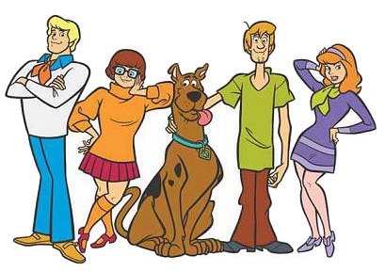  We | We are
You | You are
They | They are

Verb to be (Am, Is, Are) positive form
GRAMMAR HELPER

I am

You are
He is
She is
It is

We are
You are
They are
Know
I am Shaggy.

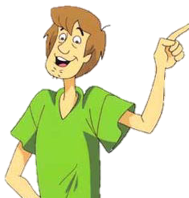
You are Fred.

He is Fred.

She is Velma.

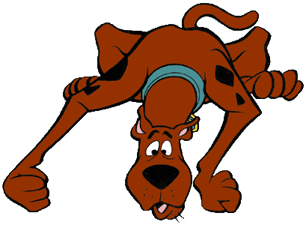
It is a dog.

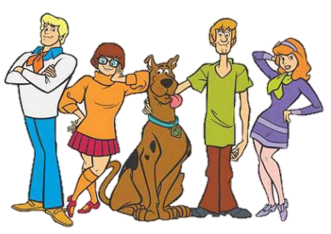
We are friends.

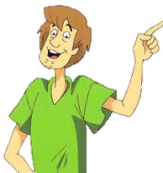
You are Daphne and Fred.
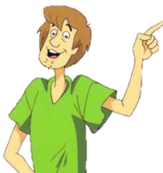
They are Velma, Fred and Daphne.

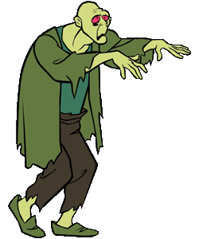
Do
Verb to be (Am, Is, Are) positive form
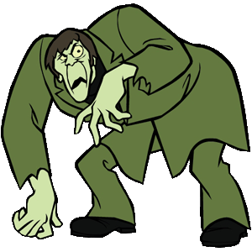
- Match.
They
He
am
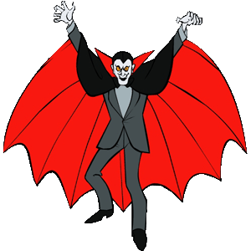
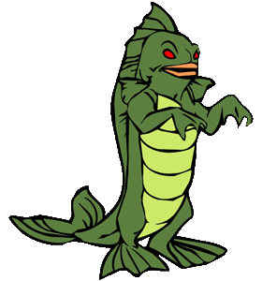
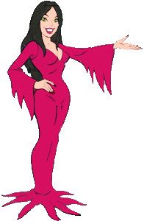
It
She
is


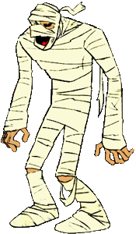
are
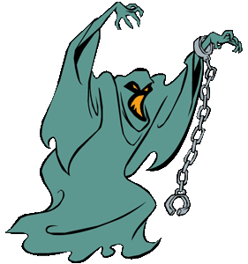
You

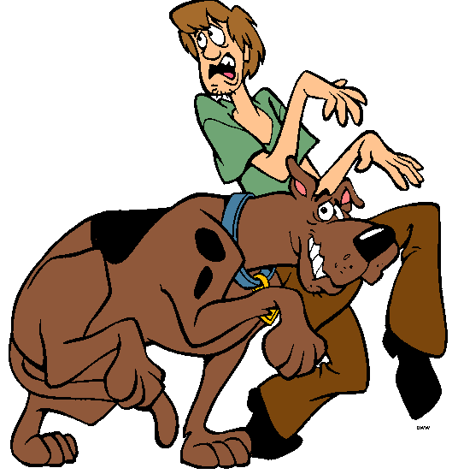
We
I

- Find the words.
B | T | R | N | I | S
P | H | G | A | R | E
X | E | S | H | E | A
W | Y | A | Z | V | M
E | C | Y | O | U | L
I | N | I | T | H | E
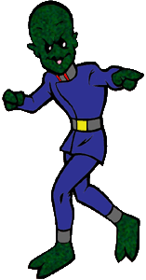
They are hidden left to right and down.

You
I
We
She

They
It
He
Verb to be (Am, Is, Are) positive form
Do
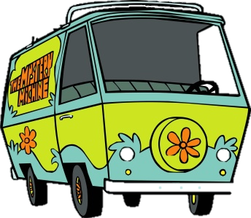
3.- Complete with am, are or is.
- It _____The Mystery Machine.

2. He _____ running.
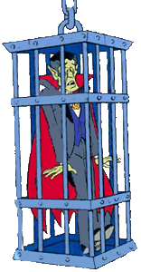

3. They _____ vampires.

4. She _____ a vampire.

5. We _____mummies.

6. You _____ a monster.

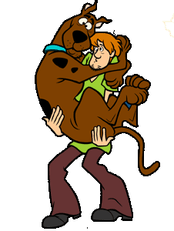
7. I _____ thin.

8. You _____ my best friend.

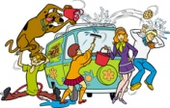
9. They ____ watchig the Mistery machine.
Do
Verb to be (Am, Is, Are) positive form
4.- Complete the crossword using the names of the characters.
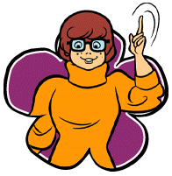
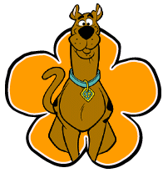
- It is…
- She is…

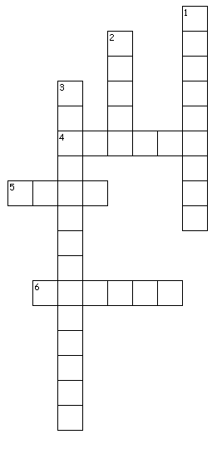

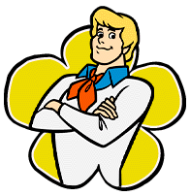
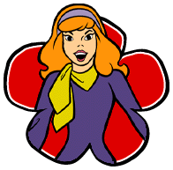

- He is…
- You are…

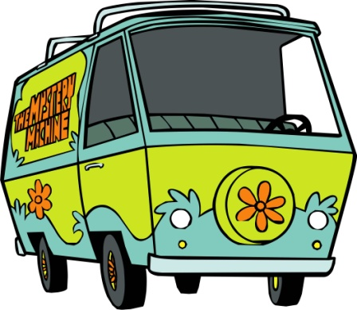

- I am…
- It is our…

