Flash Cards
Verb to be (Am, Is, Are) Negative form
  I am | I am not
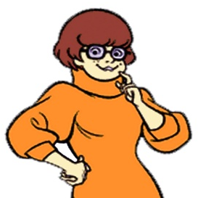  You are | You are not
He is | He is not
  She is | She is not
  Verb to be (Am, Is, Are) Negative form  It is | Flash Cards  It is not
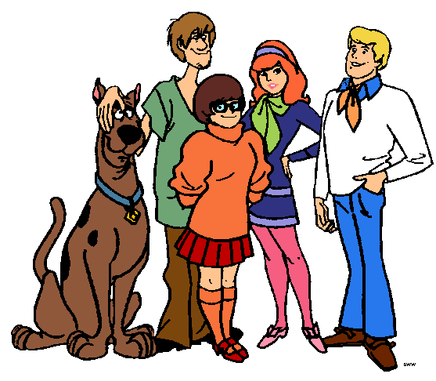  We are | We are not
You are | You are not
They are | They are not

GRAMMAR HELPER

I am not

You are not
He is not
She is not
It is not

We are not
You are not
They are not
Verb to be (Am, Is, Are) negative form
Know
I am not Daphne.
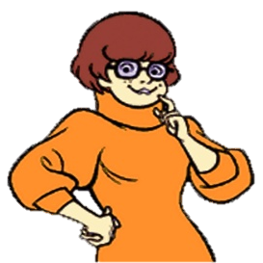

You are not Shaggy.
He is not Shaggy.
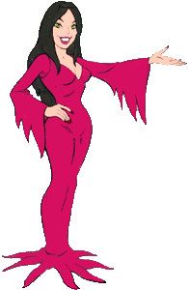

She is not Daphne.
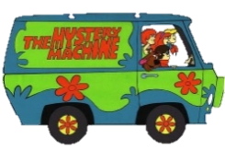

It is not a dog.
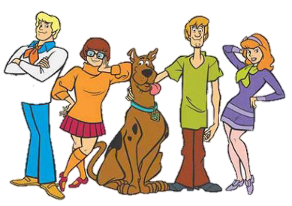

We are not sad.
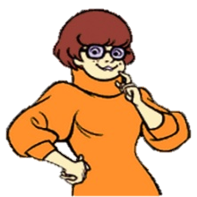
You are not sleeping .
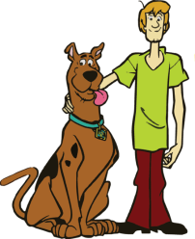
They are not dancing.
Verb to be (Am, Is, Are) negative form
Do


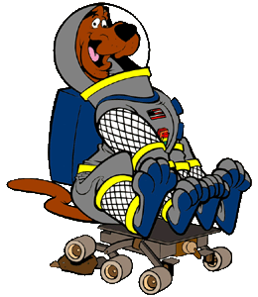
- Read and match.



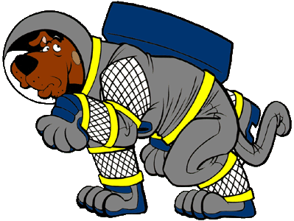

They
It
We
I
He
You
She

Are not
Am not
Is not


- Write the missing letter.
n
o
t
m
a
I

t

n

a
r
u
o

H
t
o

t

i
e
h

n
s

t

W

o

e

n

r

h
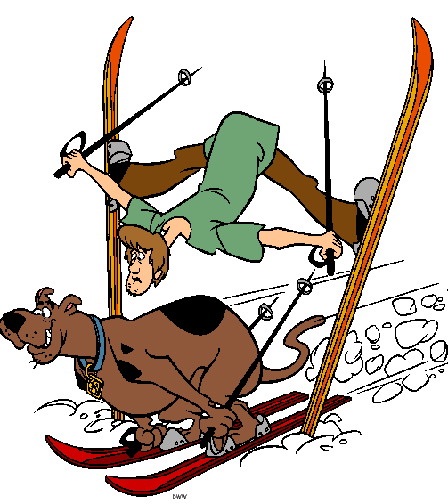
3.- Complete with am not, are not, or is not.
Do
Verb to be (Am, Is, Are) negative form
- They_____ _____ flying.

2. It _____ _______ dangerous.


3. He_____ _______ Fred.


4. You _____ _______ a vampire.

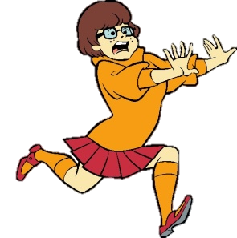
5. She_____ ______ happy.
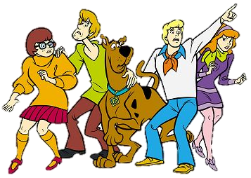

6. We _____ ______ monsters.
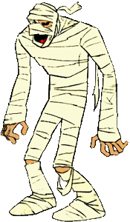

7. You _____ ______ alive.

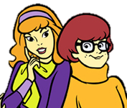
8. They_____ ______ sisters.


9. I _____ _____ Shaggy.

Do
Verb to be (Am, Is, Are) negative form
4. Find the words in the puzzle.
