Flash Cards
Verb to be (Am, Is, Are) Interrogative form
  Am I? | I am
  Are you? | You are
Is he? | He is
Is she? | She is
  Verb to be (Am, Is, Are) Interrogative form  Is it? | Flash Cards  It is
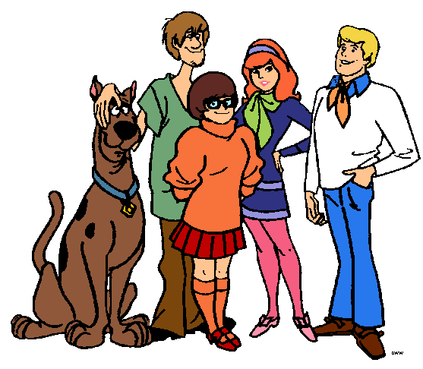  Are we? | We are
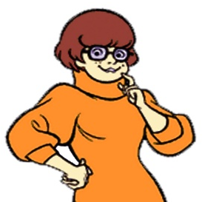  Are you? | You are
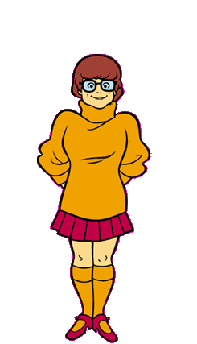  Are they? | They are

GRAMMAR HELPER

Am I?
Are you?
Is He?
Is she?
Is it?
Are we?
Are you?
Are they?
Verb to be (Am, Is, Are) Interrogative form.
Know
Am I happy?

Are you sad?

He is fat?

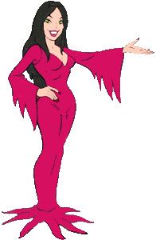
Is she pretty?

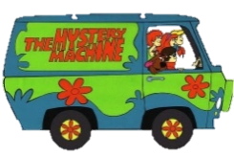

Is it a bike?
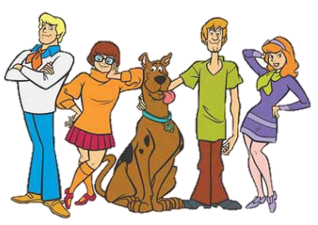
Are we braves?

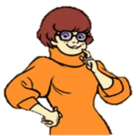
Are you thirsty?
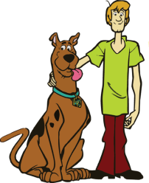
Are they angry?
Verb to be (Am, Is, Are) Interrogative form.
Do
Are they?
I am
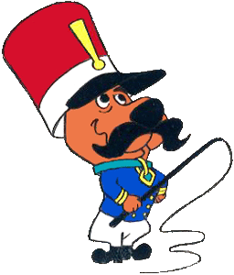
- Match
Is she?
You are

Are we?
He is

Am I?
She is

Is he?
It is

Are you?
You are

Is it?
They are

- Complete the questions.
_______ _________ happy?
I am
_______ _________ sad?
You are
_______ _________ tall?
He is
_______ _________ pretty?

Sheis

It is
_______ _________ fat?

_______ _________ hungry?
We are
_______ _________ angry?
They are
Verb to be (Am, Is, Are) Interrogative Form
Do
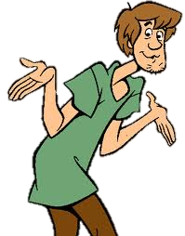
- Complete with am, are or is

- _______ I happy?
- ______ you sad?
- _______ he tall?
- ______ she pretty?
- ________ it new?
- _______ we hungry?
- ________ you thirsty?


- Complete the sentences and the questions.


I ____ Shaggy. She _____ _______ hungry.

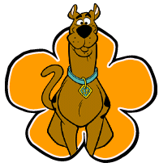
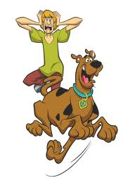
_____ ____ Scooby Doo?

We ____ ____ braves.


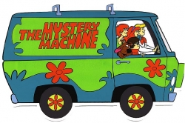

We _______ traveling.

______ _____ Fred?
Verb to be (Am, Is, Are) Interrogative Form
Do
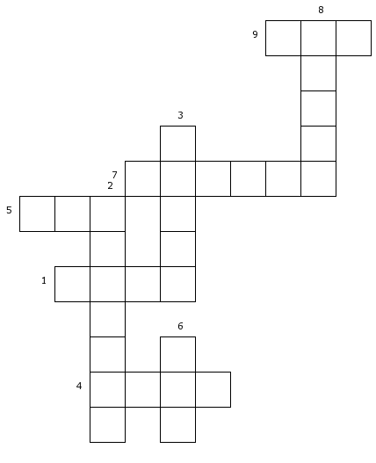
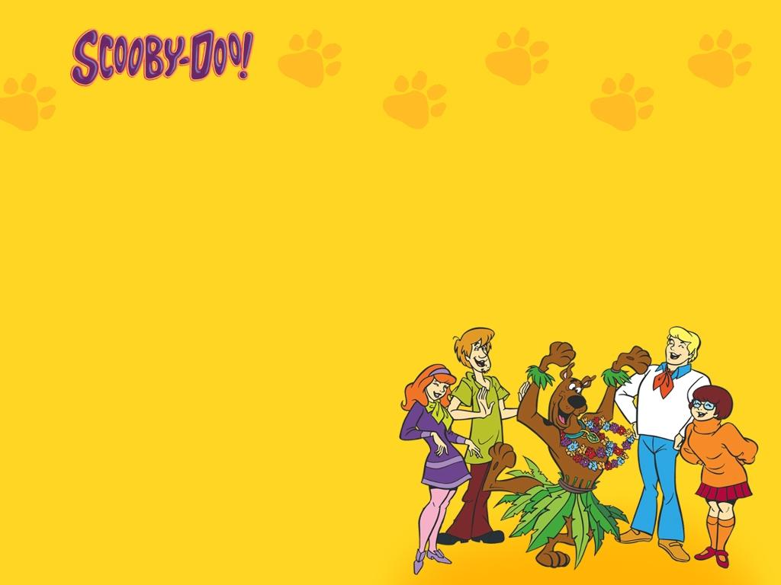
4.- Solve the puzzle.
- Vehicle that has two wheels and is moved by foot pedals.
- Needing to drink.
- Showing no fear of dangerous or difficult things.
- Of more than average height, or of a particular height.
- Synonymous of corpulent.
- Haven lived or existed for many years.
- Attractive but not extremely
- Felling resentment
- Synonymous of unhappy.

