- Listen and order
Verb to be (Am, Is, Are) Positive, Negative, Question
Be
That must be the creeper!
Ooooh…
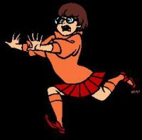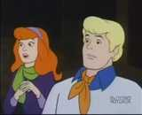
Grrrrr Crrrrr… Creeper… Creeperrrrr…
Oh! What’s that?!
Wait for me!
1
Grrrrr Crrrrr….
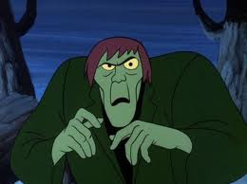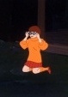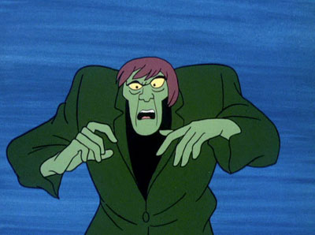
Dear, that’s better.
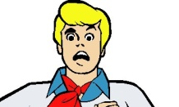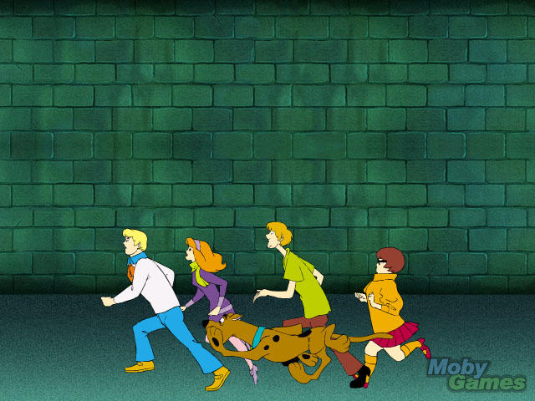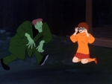
And I think it’s time to leave, everybody run!
Grrr
I think he wants the blank paper the guard gave us
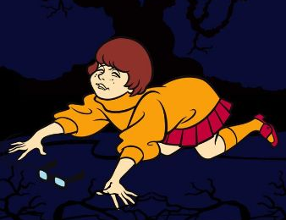
What’s going on around here? run for what?
Be
Verb to be (Am, Is, Are) Positive, Negative, Question
- Read and underline YES or NO
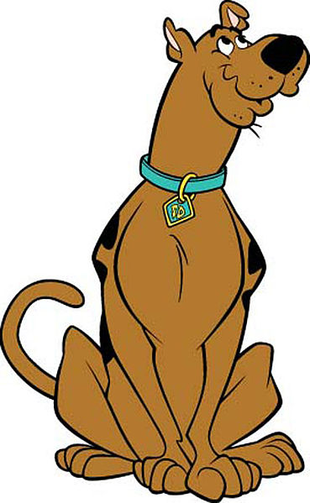
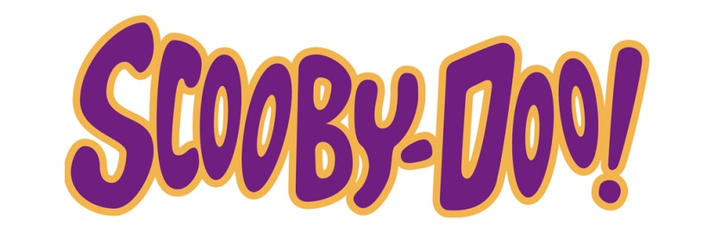
Scoobert "Scooby" Doo is the eponymous character and the protagonist in the Scooby-Doo animated television series created by the popular American animation company Hanna-Barbera. Scooby-Doo is the pet and lifelong companion of Shaggy Rogers.
In all versions of the character, ‎Scooby-Doo and Shaggy share several personality traits, they are not so braves, they mostly being cowardly and perpetually hungry. But their friends (Velma, Daphne and Fred) encourage them to go after the costumed villains, usually with "Scooby Snacks", a biscuit-like dog treat or cookie snack, though Scooby's inherent loyalty and courage does often force him to take a more heroic stance.
- Scooby and Shaggy are heroes. YES NO
- Scooby-Doo is the pet of Velma,
Daphne and Fred. YES NO
- Scooby Doo eats “Scooby snacks” YES NO
- The creator of Scooby is Hanna Barbera YES NO

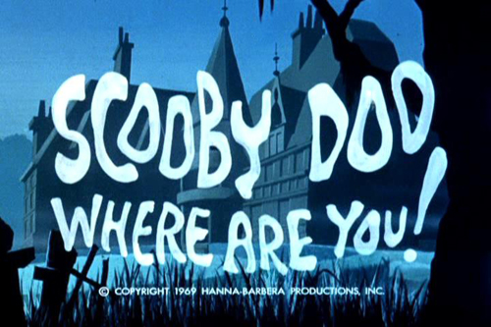
Listen, read and write to complete, then sing the song.
Verb to be (Am, Is, Are) Positive, Negative, Question
Be

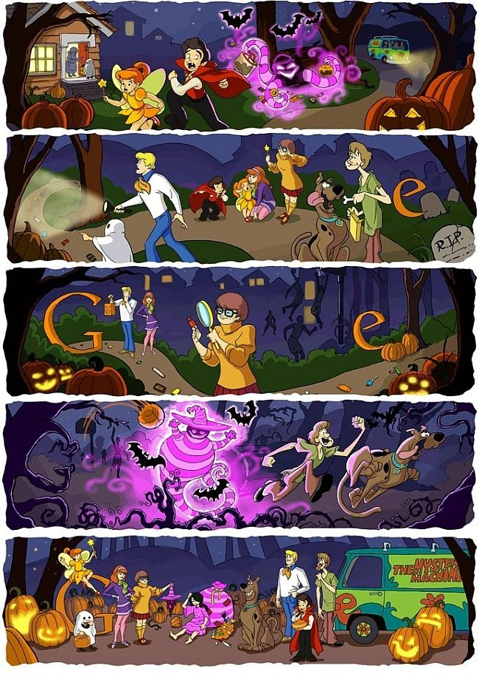
Scooby-Dooby-Doo, Where _________You?
We got some _______to do now.
Scooby-Dooby-Doo, Where ________ You?
We need some help from you now.
Come on Scooby-Doo, I see _____... pretending _____ got a sliver
But you are _____ fooling me, cause I can see, the way _____ shake and shiver.
You know ______ got a mystery to solve,
So Scooby Doo be ready for your act. [Scooby Doo] Uh-uh Uh-uh
Don't hold back!
And Scooby Doo if you come through
you ____ going to have yourself a scooby snack!
That's a fact!
Scooby-Dooby-Doo, here ______ You.
You______ ready and you _______ willing.
If _____ can count on ______ Scooby Doo,
I know you'll catch that villian.

Be
Verb to be (Am, Is, Are) Positive, Negative, Question
I am Shaggy. I am thin. I am not fat.
My pet is a dog. It is very funny. It is not brave.
Its name is Scooby doo.
My mother is pretty.
My mother is not fat.
My father is very responsible.
My father is not grumpy.
My best friends are Fred, Velma and Daphne.
We are living in The United States of America.

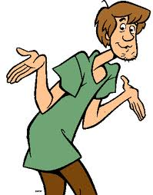
4.
Do you have a pet?
What’s its name?
Who are your best friends?
Where do you live?
Share this information with your classmates.

SELF ASSESMENT.
I learned the verb to be in simple present
More or less, well very well.
I can understand sentences in positive and negative form with the verb to be in simple present.
More or less, well very well.
I can ask questions using the verb to be in simple present
More or less, well very well.

