

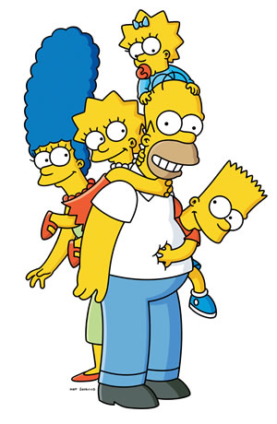

Flash Cards
Simple Present
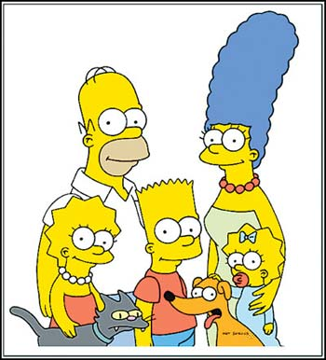  I | I like
  You | You like
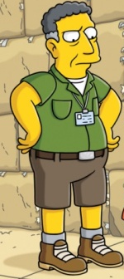  He | He likes
  She | She likes
Simple Present  It | Flash Cards  It likes
We | We are
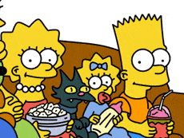  You | You like
  They | They like
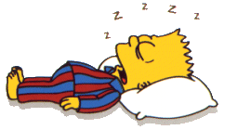


To cry
To go
To sleep
Know
Simple Present positive form

I cry
He cries
She cries
It cries

You cry
We cry
They cry

I go
He goes
She goes
It goes

You go
We go
They go

I sleep
He sleeps
She sleeps
It sleeps

You sleep
We sleep
They sleep

We use the Simple Present to talk about:
Habits and routines
facts
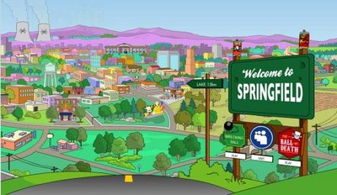
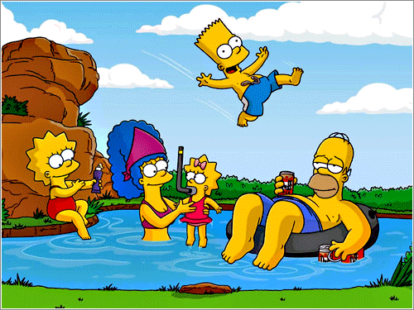

They go to the lake every Summer
We live in Springfield.

Things that are true in general
Feelings and emotions
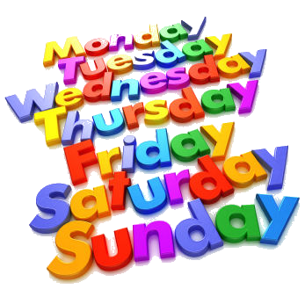


Sunday comes after Saturday.
You like meat.
Know
Simple Present positive form
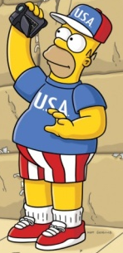
We dance very well.
I Live in USA.



You like donuts.
.
You play a lot.

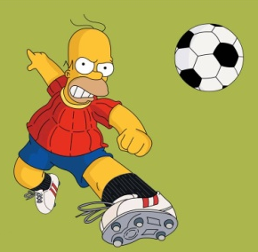
She cooks very well.
He plays soccer every saturday.

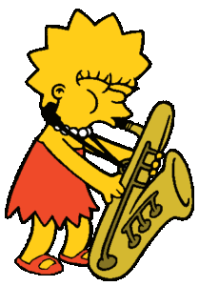
Remember

I you we they
Like, go, cry

He she it
Likes, goes, cries
She has a sax.



It comes from Mexico.

Do
Simple Present positive form
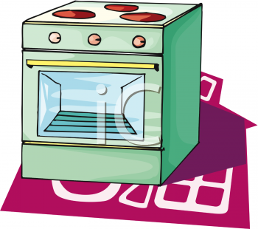
- Match.
bake
I
We
she

He
it
bakes
they
you

- Choose the correct word.
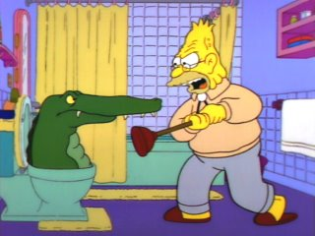
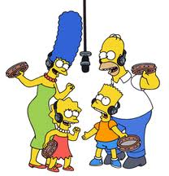
Clean / cleans sing / sings

I clean the toilet. We often _________ songs.
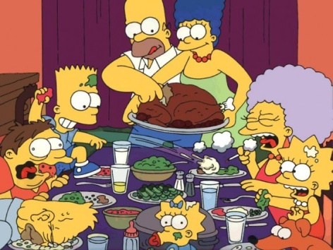

Eat /Eats cook / cooks

They _______ meal every day. He ____________ very well.
Simple Present positive form
Do

Write the sentences.
1.
I
have
a
dog

1. I have a dog
2.
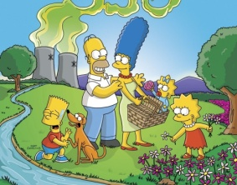
Springfield
in
I
live


2.
3.

cooks
well.
He
3.
4.

5.
sax.
has
She
a
4.
From
It
Australia.
comes
6.
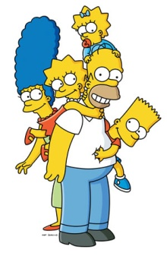
5.
speak
We
English
very well.
6.


7.
You
donuts.
like
7.
eat
You
a lot
9.
8.
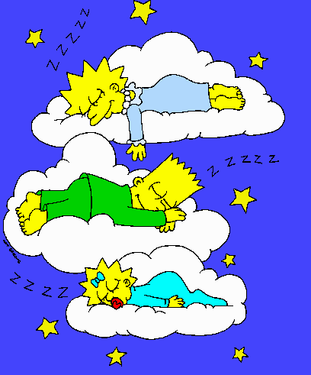
8.
They
sleep
afternoon.
every
9.

