Values and Violence
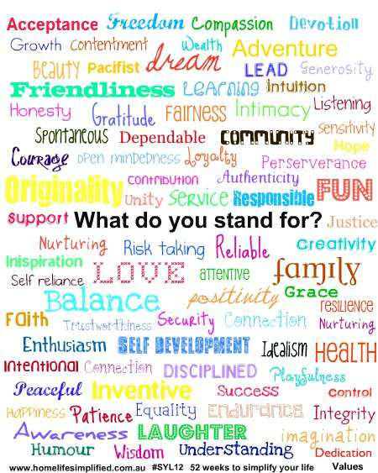

UANE
María Guadalupe Soriano Santoyo
5th semester of L.I.
Nowadays to talk about Values and Violence is very difficult, because the themes are opposite. Usually we hear and see not only in the news of other countries but local news and even comments from our neighbors and relatives, unfurtunately the violence is taking ground in our lives.
There are a lot of words to describe values, but I think that values are not only definitions, descriptions or meaning words, values are attitudes and if we as a society have positive attitudes we can obtain positive results.
It is the cause and effect. Trough the years the society has developed different types of violence, it always will exist, but in our hands is to stop it. How? , well, it is simple and complicated too, the answer is: Values. It is a hard work but it is not impossible. And if you are asking yourself: simple and complicated? The answer is: Yes, it is. Simple, because we know what the values are, and complicated because we (as mexicans) don’t respect values or do not know how to show them. In consecuence the Violence is present and growing in our daily lifes.
Violence. We can blame the government, the economic situation, the social status or whatever, but to accept the responsibility of being a better person is only ours. However we were not born with values learned, we know it by imitation, the first teacher in our life are our parents and many of the attitudes that now we have, had been learned from them and at the same time they learned from their parents too, so we are a chain of consequences.
I remember that when I was a child my father asked me about honesty and a lot of times I and my brothers bring him a lot of phrases to describe the word, he always said the same: “ Honesty can’t be definited, it must be demostrated”, I did not understand at the moment, but now I understand what my father wanted to teach us. He wanted to teach us to be people with values.
Now I am convinced that the absence of moral values lead to violence.
The multiple occupations that today we do, not allow us to give them the proper teaching of values to out cchildren, we assume that they will learn it watching videos, movies, stories and fables in the school, with the teacher, as a class and these will be enough, the result: disoriented children, teenagers with problems of depression, drugs, gangs, etc, in summary: violence.
What do you stand for? Answer us this question ourselves connects us to the origin of our family, because precisely, we represent our family, in fact the soul of our ancesters, their customs, attitudes, personalities in one word the essence of our personality is given by the values learned with our relatives.

In fact, the cause of violence is the absent of values, and the consecuence of this absent is violence.
Have you ever heard in recent days that a youg man committed suicide?, Or that there was a shoothout and died teenagers or children using drugs?, Have you heard there are rappers?, Men or women who abuse their children? Or that children in schools do not respect their classmates and teachers?, Thieves?, murderes? Rapists?... Now, these are common news and I think… What happened?, When they loose their values?, They know what values are?, Who is the responsible of that violence act?, Sadly, we can not change the world, but we can do something else.
The best thing that we can do is to try to be a good person and promote the values that you have with your family, friends and the people around you. In fact, you do not change all the world, but you can do better your environment and change the chain of effects.

Ma. Guadalupe Soriano Santoyo

